Scorecard Page Eagle Point Golf Course Website Content
Eagle Point Score Card
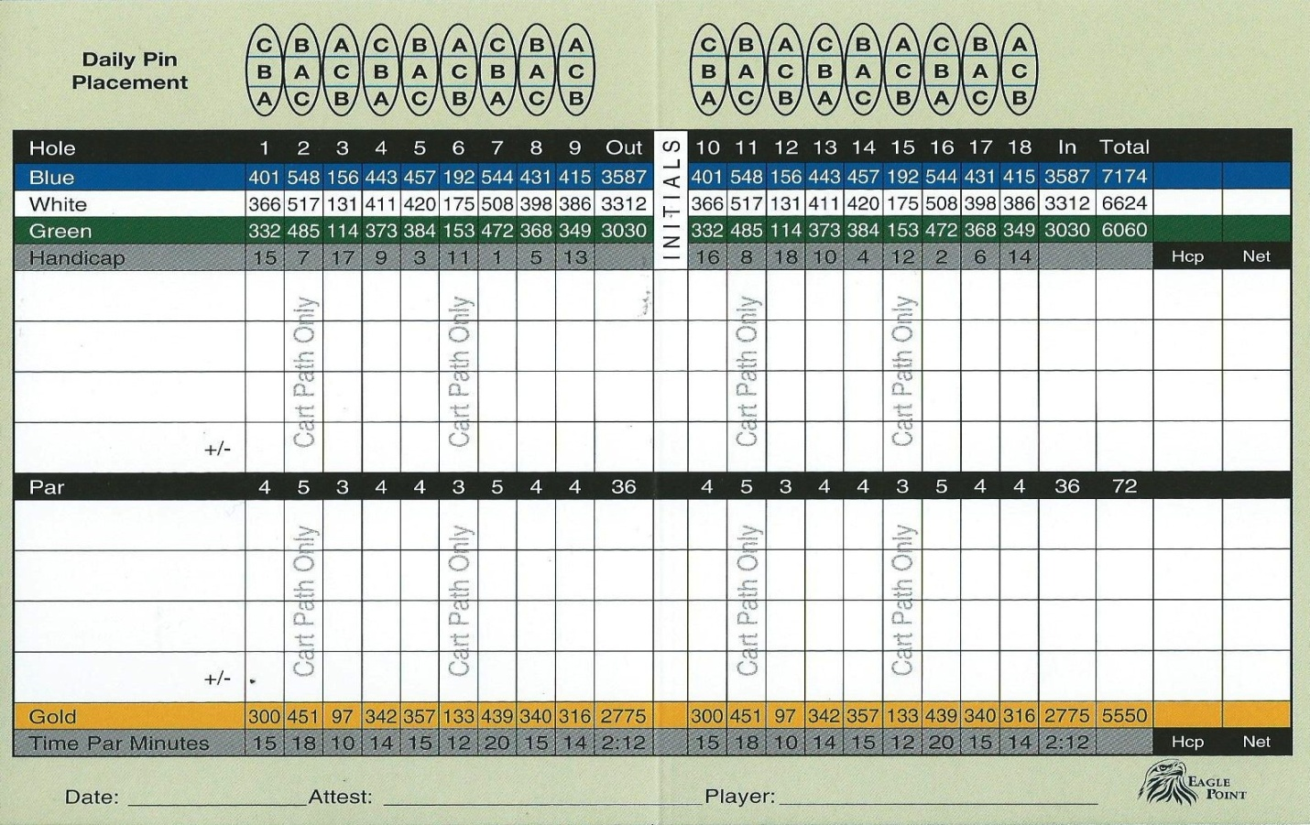

The MD of Opportunity #17 would like to acknowledge the following hole Sponsors.
Hole #1- Aces (Auger Construction & energy supply)
Hole #2- Eric Auger & Sons Contracting
Hole #3- Wabasca Home Hardware
Hole #4- Noralta Lodge
Hole #5- Schroder Oilfield Services
Hole #6- Luxury First Hotel
Hole #7- Aim Oilfield Services
Hole #8- Clear Stream (BVL)
Hole #9- Laricina Energy

